How to get ID user who login in application
Messy =kacau
Snail=siput
Pace:gerakan
Tangle=pengusutan
Rebel=pemberontak
Odious= menjijikkan
Expend=membelanjakan, membuang
Terrible=dasyat
Bend=belokan
Grand=besar
Waded=mengarungi
Mess=sembraut
Grave=serius, parah
Surgery=pembedahan
Bemoan=meratapi
Obsessing=terlalu mempengaruhi pikiran
Defend=mempertahankan
Complicit= keterlibatan
Comply=mematuhi
Refuge=perlindungan
Refuse=sampah atau bias juga rongsokan
Acquired=mendapat
Crafted=ditukangi
Sheer=tipis
Desire=hasrat
Notice=maklumat
Tend=cenderung
Tempt=menggoda
Mess=kesembrautan
Spoil=memanjakan
Façade=menghadapi
Abbreviate
I just writing something, But I will change my future and make my parent proud of me. I always hardworking and I will show that I can do that.
Assertation=pernyataan
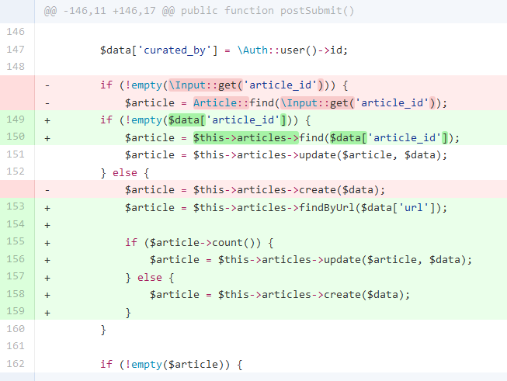

https://guides.github.com/introduction/flow/
http://www.php-fig.org/
prosa=berupa tulisan
fascinating artinya menarik hati
revamped=diubah.

